

**Project Milestone 2: Frontend**

**User Interfaces**

Presented to

**Sir, Majid Hussain**

In partial fulfillment

of the requirements for the course of

***DATABASE SYSTEMS***

By:

Hafsa Imtiaz (22i - 0959)

Areen Zainab (22i - 1115)

Aoun Jee (22i - 1052)

Section H

**FRONTEND REPORT**



**STARTER PAGE :**

When you open up the Flex Trainer app, you are greeted with the starting page where you are greeted with the introduction to Flex Trainer as well as two choices to either log into your already existing account or sign up for a new account.

**LOGIN PAGE :**

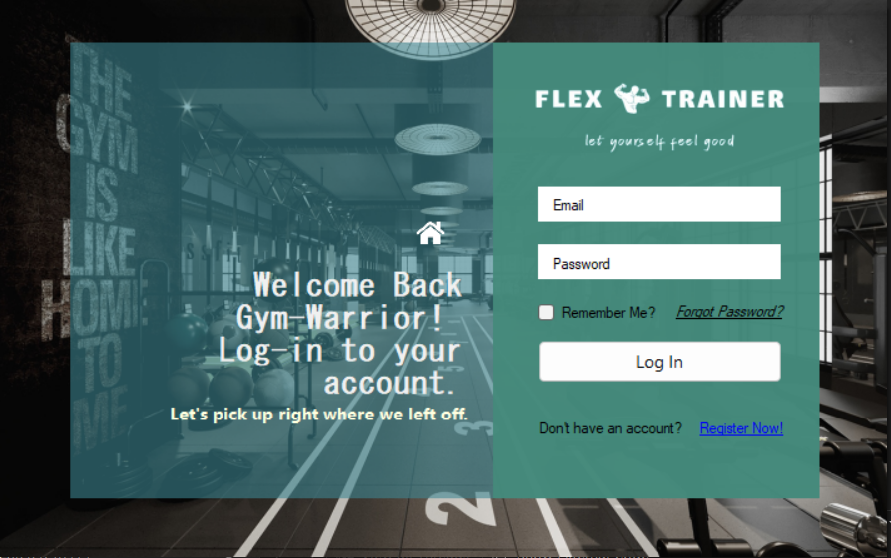

The Login option opens the above page where you can enter your email address and password to access your account. The Flex Trainer app will recognize if your account information matches that of a member, trainer, admin, or gym owner and log in accordingly. Additionally, there is a “Register Now!” option if you do not have an account and want to create a new account.

**GENERAL USER SIGN-UP:**

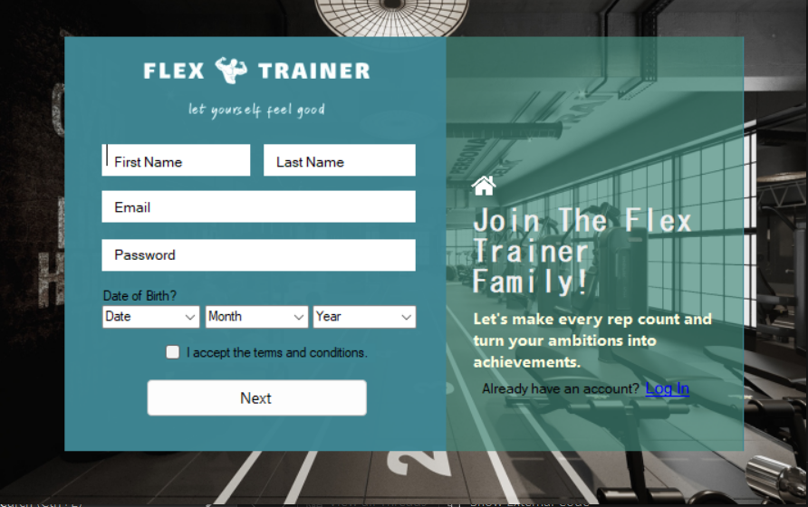

Suppose you have clicked on the “Register Now!” or the Sign-Up button (from the main menu) then you are greeted with the General User Sign-Up page where you can enter your appropriate information - that is common to all users. Therefore there is no distinction about your role currently. There is also the option to shift to the Log-In page to access your existing account.

After clicking “Next” you move onto the next page where you can decide whether you want to register as a :

* Member
* Trainer
* Gym Owner
* Admin

**MEMBER SIGN-UP:**

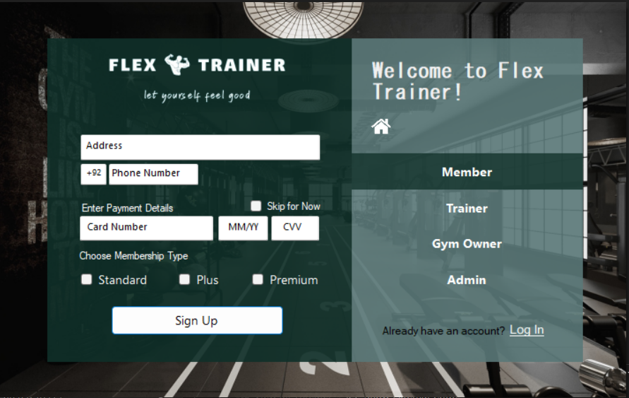

The Member Sign Up page also gives you the option to select what type of membership you would want to subscribe to.

**GYM OWNER SIGN-UP:**

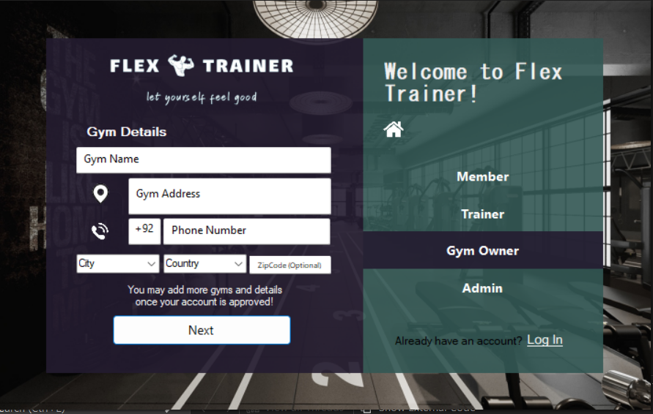

The Gym Sign Up page requires you to add the location of the Gym you work for. This information is then checked and if you have inserted the proper information then your account is approved.

**GYM ADMIN SIGN-UP:**

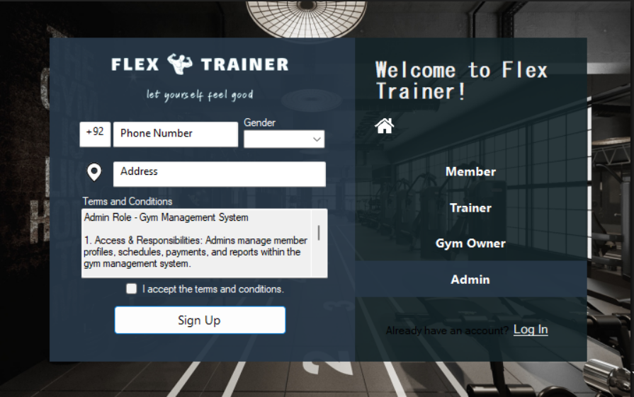

The information required for the Gym Admin Sign-Up is given above with the slight difference that you are required to accept the terms and conditions exclusive to the Gym Admin before signing up.

**GYM TRAINER SIGN-UP**:

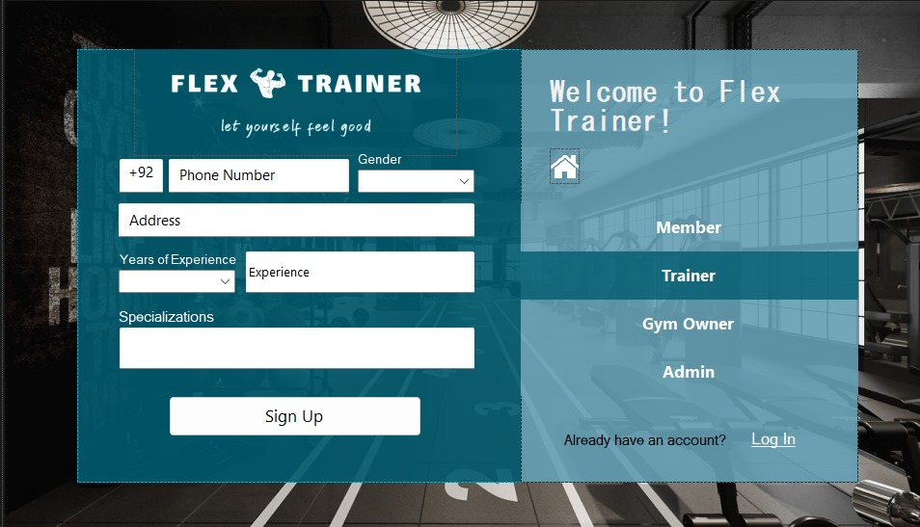

The main difference between the Trainer’s SignUp and the previous ones is that the trainer requires you to input years of experience along with experience and what fields you (the trainer) specialize in. Apart from that, everything else is the same.

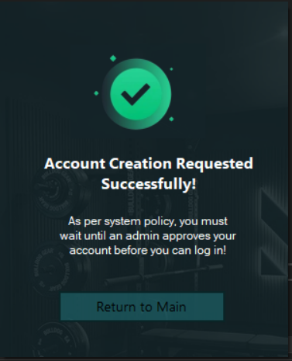

Note: Upon Signing Up as either an Admin or a Gym Owner, the following form is displayed.

The purpose of this form is to reinforce the security of the system wherein, these users are not given immediate access to the system - instead, they have to await approval!

**MEMBER INTERFACE**

MEMBER DASHBOARD:

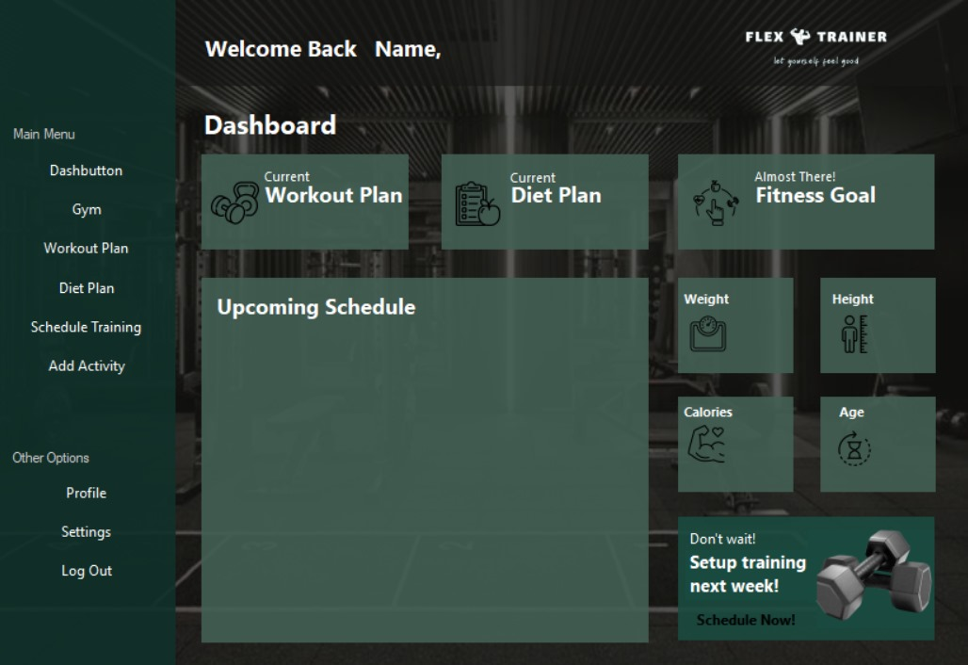

When you Log-In/Sign-Up as a Member you are initially greeted with the Dashboard page. This shows all the necessary information about the Member such as weight, height, age, upcoming schedule, and many more. From here you can navigate to the “Main Menu” and “Other Options”.

MEMBER WORKOUT PLAN:

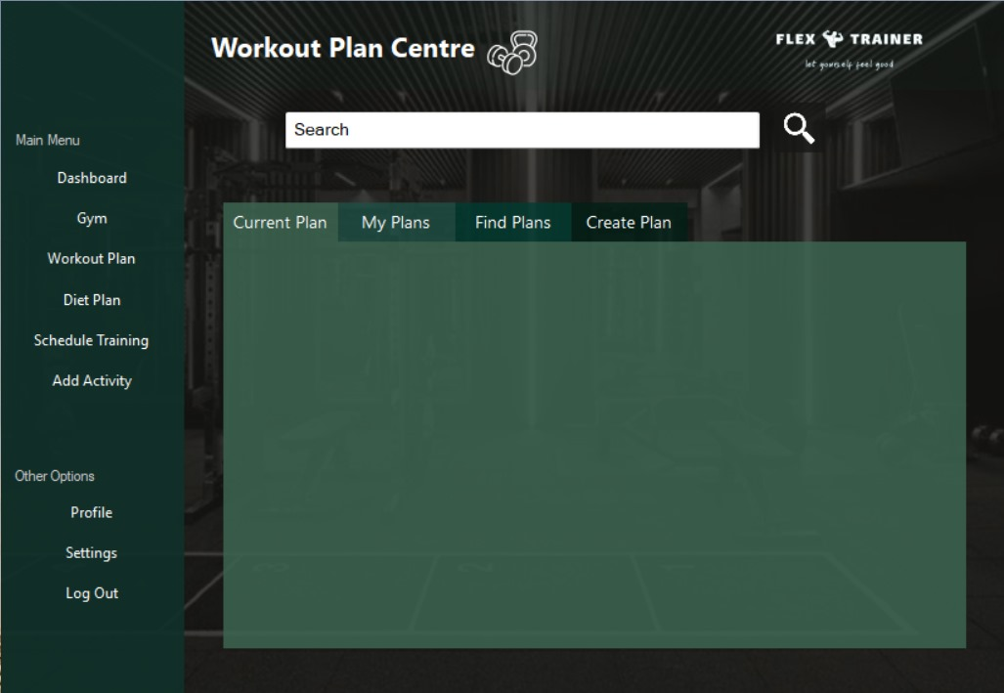

Moving to the Workout Plan Centre, you have four options to choose from

* Current Plan → shows the current workout plan you are taking.
* My Plans → shows the plans you have created yourself.
* Find Plans → allows you to search and use the workout plans others have created.
* Create Plan → gives you the ability to create workout plans that you or yourself can use and can also allow others to use your plan.

MEMBER DIET PLAN: 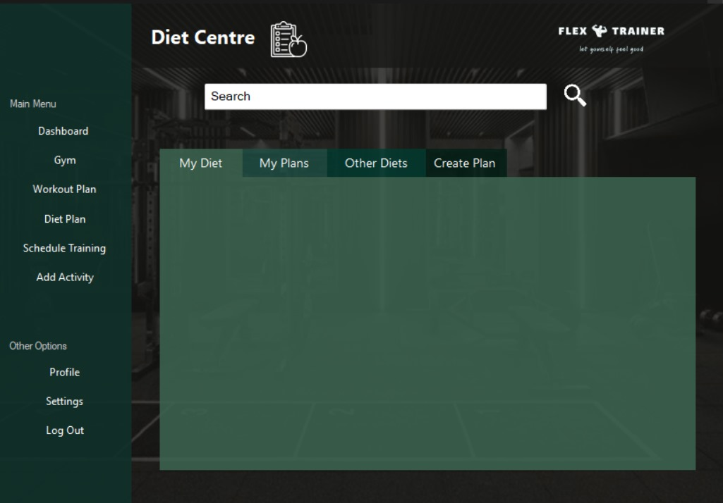

When you select the Diet Plan option from the Main Menu, you can view the above page where you can view the following options :

* My Diet → the current diet you are on.
* My Plans → the different diet plans that you have either saved or created.
* Other Diets → allows you to choose from the different diets that others have curated.
* Create Plan → allows you to create diet plans that you or yourself can use and can also allow others to use your plan.

MEMBER SCHEDULE ACTIVITY:

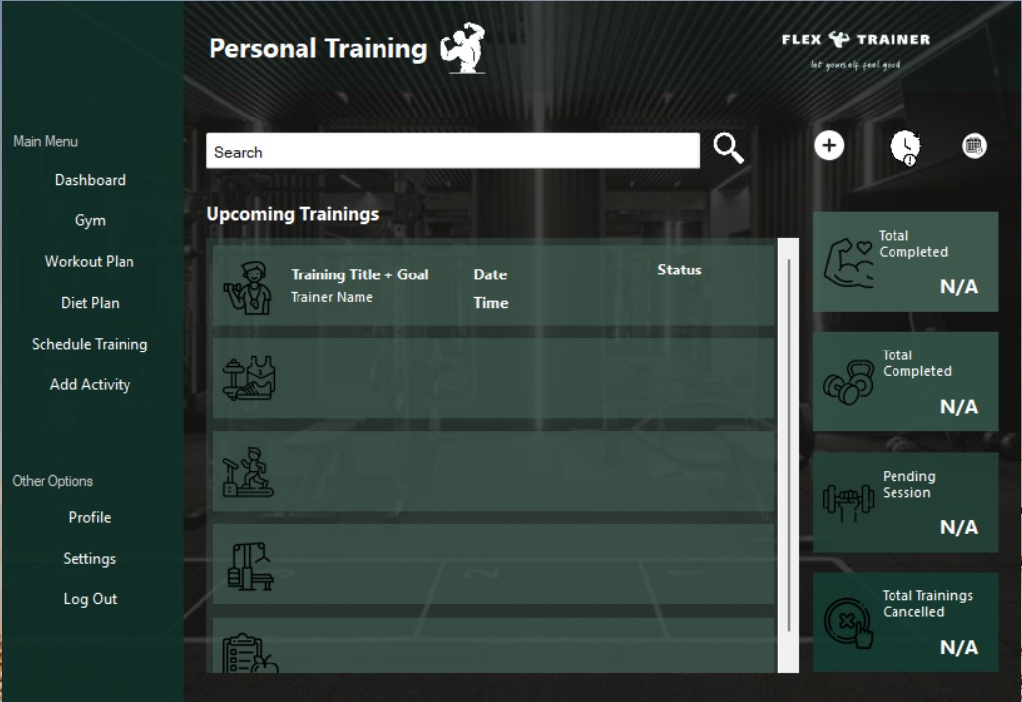

After clicking on the Schedule Training option from the “Main Menu” you will be able to view the Personal Training page where you can view the details of your training such as the Total Completed training, the Upcoming Training Sessions, and many more. If you click on the plus sign next to the search menu you will be able to view the next page,

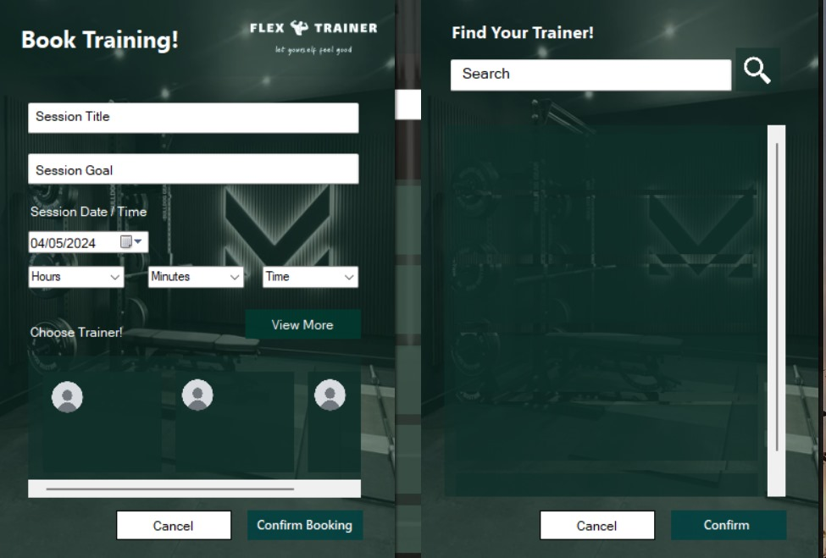

From here you can book a training session with a trainer of your choice. Originally, you will be able to only see a few trainers from the “Choose Trainer!” option but if you click “View More” then another panel will appear from where you can “Find Your Trainer!” of your choice.

MEMBER DIET PLAN:

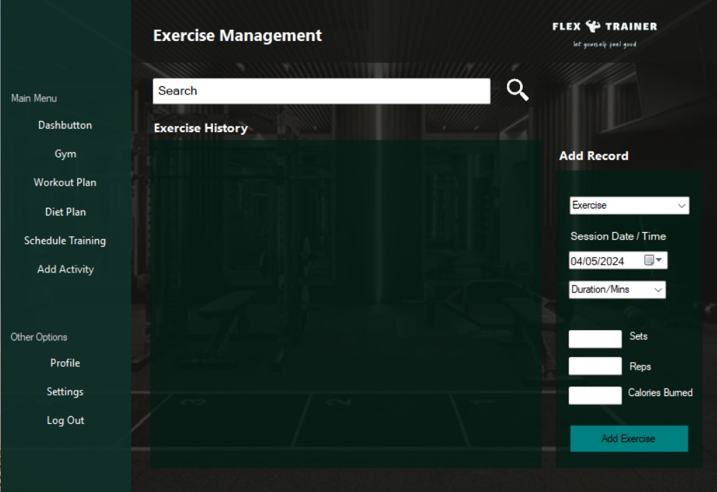

When you click on the Workout Plan option from the “Main Menu” you can see the above page from where you can Add the records for the exercise you have completed along with all the details of that exercise.

MEMBER PROFILE SETUP :

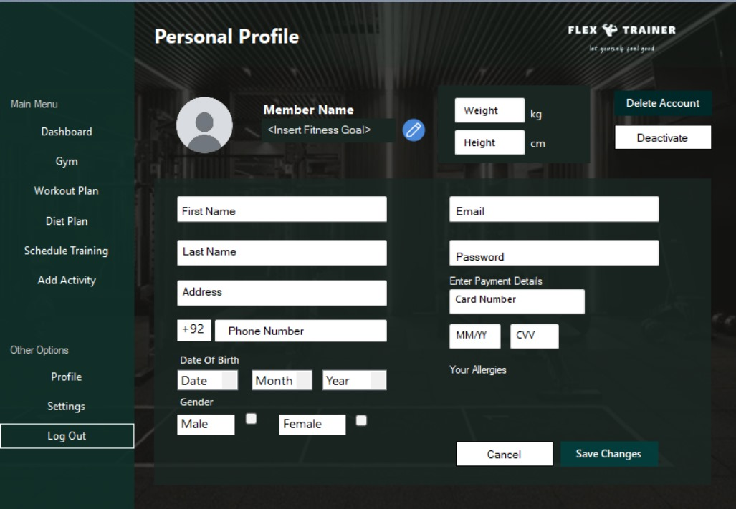

Finally, for the Member Interface, you have the “Personal Profile” section where you can edit and save changes to all the necessary information you entered earlier along with adding a description to your Account as you like. Furthermore, you can also delete or deactivate your account.

**GYM OWNER INTERFACE**

GYM OWNER DASHBOARD :

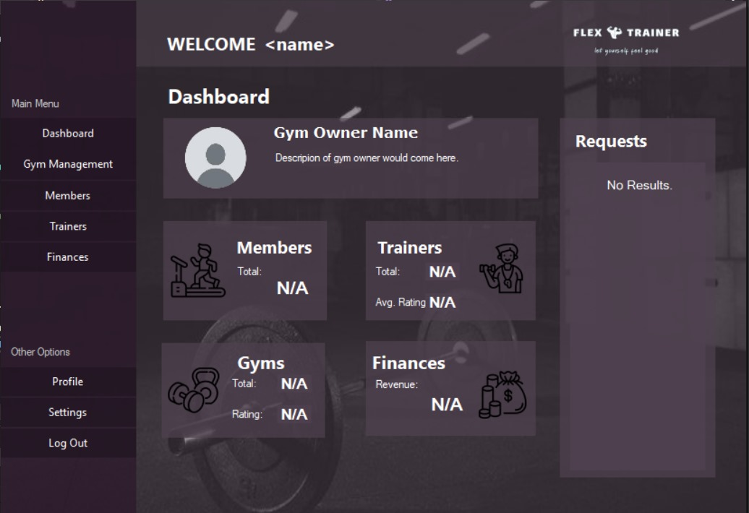

If you Log-In as a Gym Owner, you are first presented with the Dashboard page where you can view all the Members and Trainers at your gyms and all the Gyms that you own along with their finances.

Similar to the Member Dashboard you can access the “Main Menu” options from the bar to the left.

GYM MEMBER MANAGEMENT :

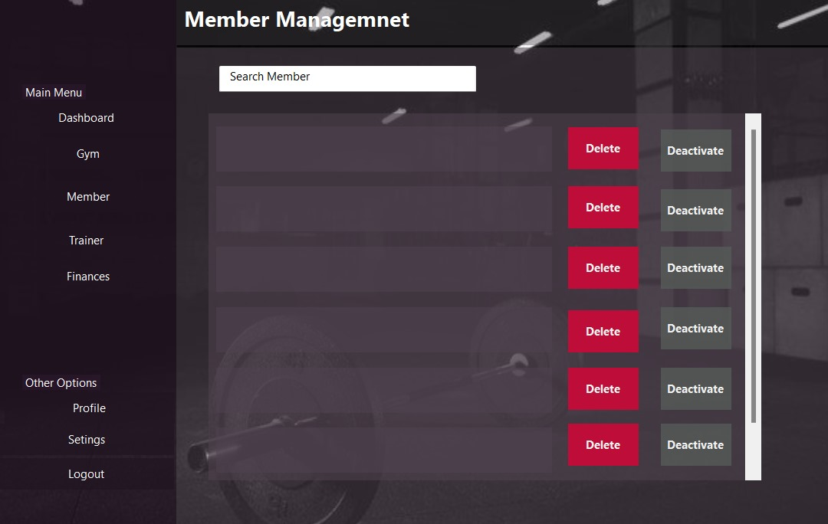

This section allows the Gym Owner to view the members at their gyms. Additionally, the gym owner also has the ability to delete or deactivate the accounts of the Members. They can also search and look up the members at the gym.

GYM OWNER TRAINER MANAGEMENT :

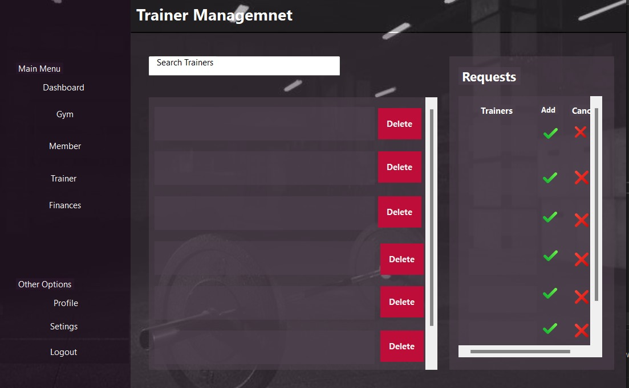

Suppose you have clicked on the Trainer Management option, then you will be presented with the above page where you can view the pending requests from the Trainers who want to join your gym and also the current trainers working at your different gyms.

GYM OWNER FINANCE MANAGEMENT:

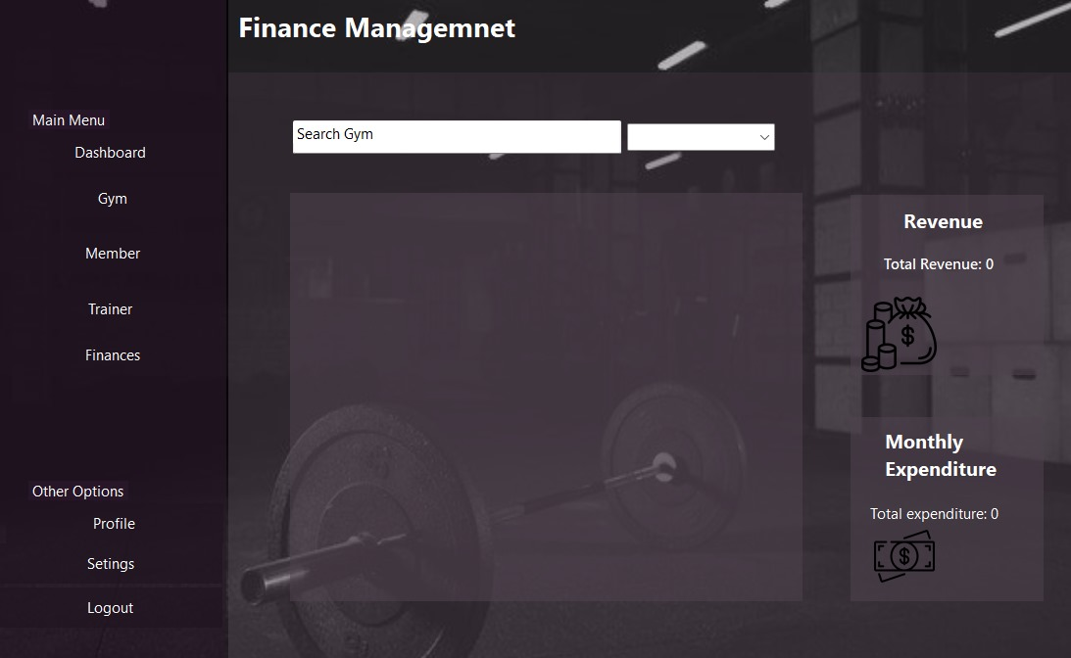

From the Finance Management section of the Gym Owners account you will be able to search and view any gym from the ones you own and view their revenue and monthly expenditures.

GYM OWNER PROFILE :

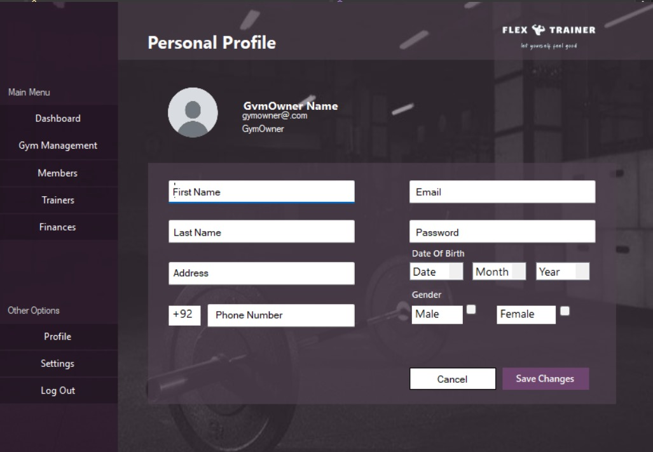

Similarly to the Member, the Gym Owners can also update their information as they like.

**GYM ADMIN INTERFACE**

GYM ADMIN DASHBOARD :

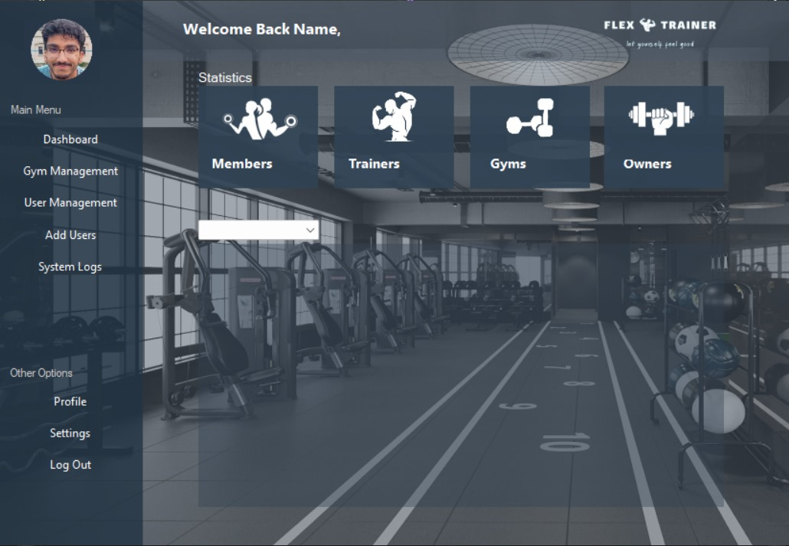

The above interface is for the Admin. Similarly to the Gym Owner, you can view the different members and the trainers at the gym and at which gyms. Additionally, you can also view which Owners own which gyms. You are also presented with the option to manage the Gyms and the Users in the database along with the option to add users and view the system logs.

GYM ADMIN PROFILE SETUP :

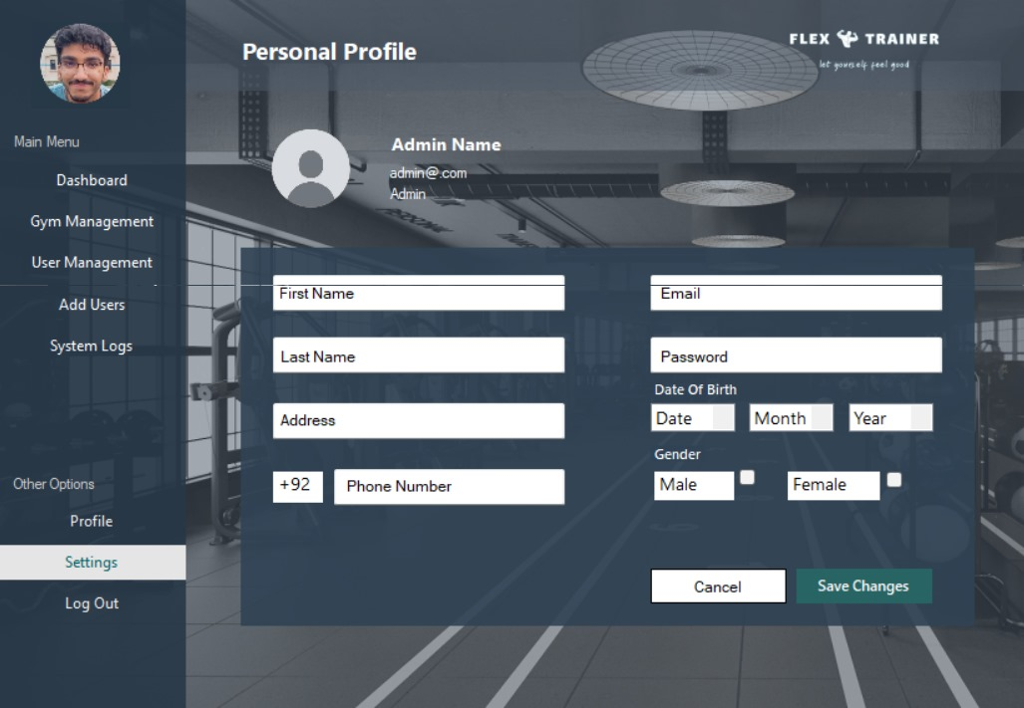

Similarly to the Member and the Gym Owner interfaces, you are provided with the option to change your profile’s information.

**GYM TRAINER INTERFACE**

GYM TRAINER DASHBOARD :

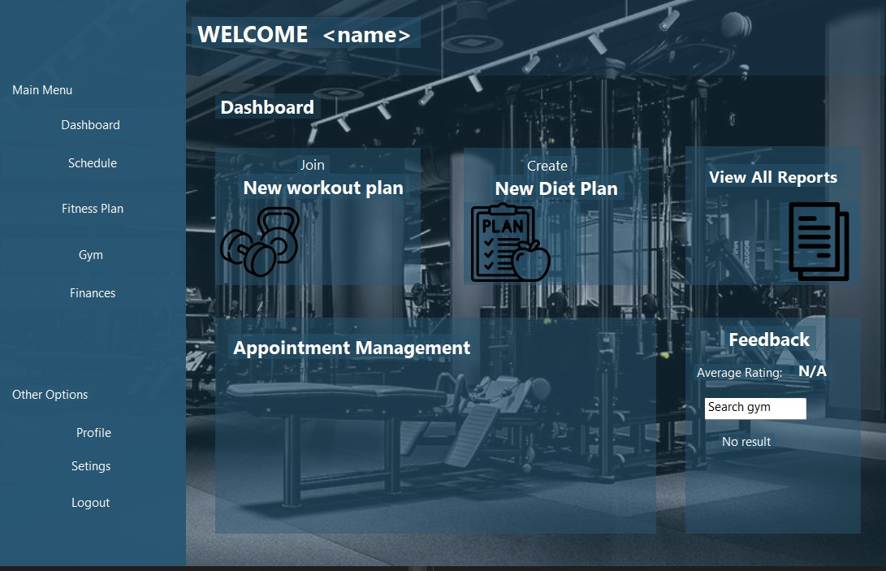

The Gym Trainer Dashboard provides the trainer with a variety of options. The trainer can join new workout plans and create diet plans. They can also look up the reports and the feedback from their clientele (members). Also, they can manage the different appointments they have with the members at the gym(s).

GYM TRAINER APPOINTMENT REQUESTS :

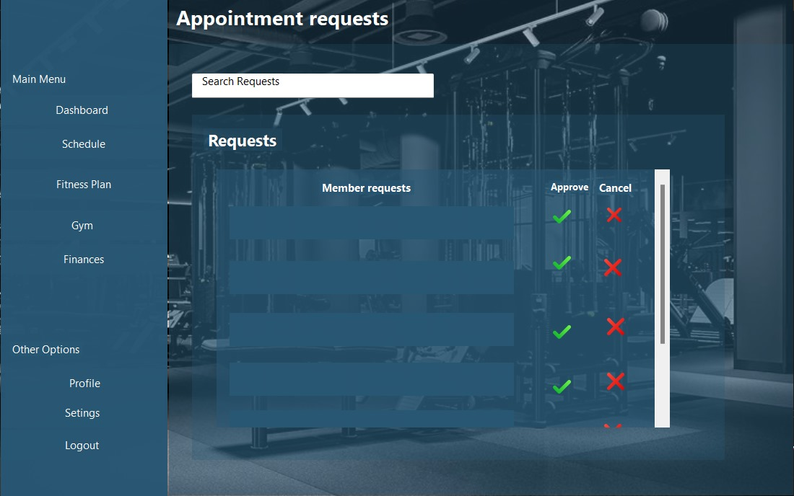

After clicking on the schedule option from the Main Menu you will arrive at the Appointment Requests section of the User Interface. From here you can check which members have requested you for Training Sessions and the choice is with you whether to approve or cancel their requests.

GYM TRAINER PROFILE SETUP :

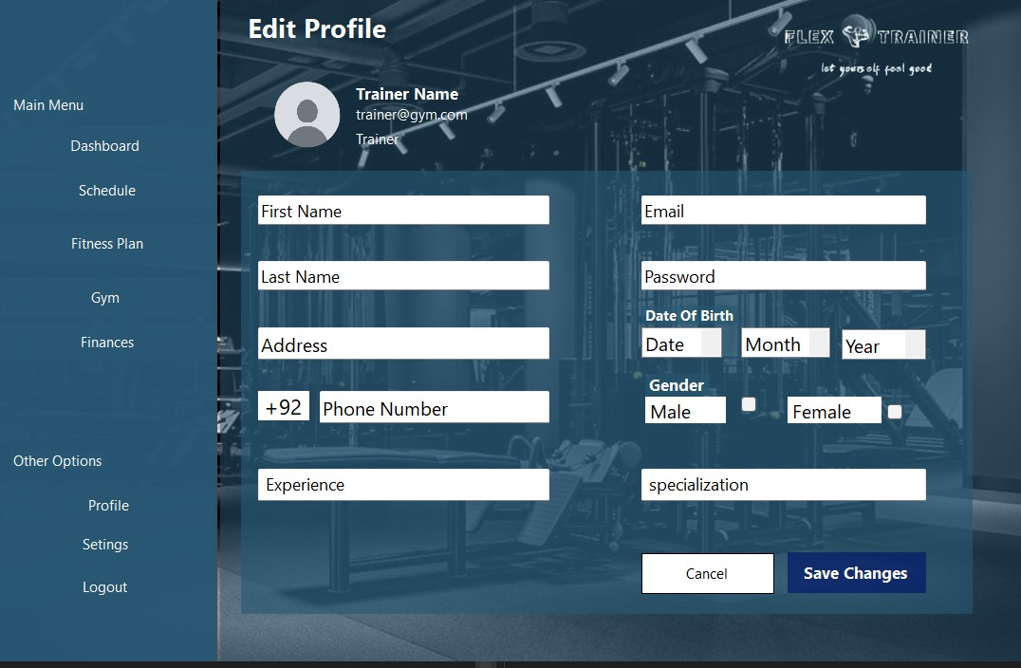

The Gym Trainer Profile can be edited similarly to the previous users mentioned. Two new options are added for Experience and Specialization in case the trainer wants to change them.